Malayan colleges laguna

Pulo, Diezmo Road, Cabuyao, Laguna

**De Ramos Dental Clinic Information System**

A Project Title Proposal Presented to

Malayan Colleges Laguna

College of Information Technology

In Partial Fulfillment

of the Requirements for

ACT176P

By:

Boholst, Cruzald C.

**Prof. Rhea N. Tortor**

Course Adviser

January, 2019

Table of Contents

**1.0 Introduction4**

1.1 Background of the Study4

1.2 Statement of the Problem5

1.2.1 General Problem5

1.2.2 Specific Problem5

1.3 Objectives of the Study5

1.3.1 General Objectives5

1.3.2 Specific Objectives6

1.4 Significance of the Study6

1.5 Scope and Limitation6

1.5.1 Scope7

1.5.2 Limitation7

**2.0 Methodology of the Study8**

2.1 Iterative and Incremental Development8

**3.0 Review of Related Studies and Literature10**

3.1 Dental Clinic and Management System10

3.2 Dental Information System10

3.3 Information Systems in Dentistry10

3.4 dentIst: Dental Information System 2.010

3.5 Electronic Dental Records11

3.6 Dental Clinic Management System11

3.7 Design and Implementation of a Clinical Management System11

**4.0 Theoretical Framework12**

4.1 IT-Related Theories12

4.1.1 Information Systems12

4.1.2 Database Management Systems12

4.1.3 Transactional Processing Systems12

4.1.4 Human-Computer Interaction12

4.2 Non-IT Related Theories13

4.2.1 Reports13

4.3 Summary13

**5.0 Data Gathering and Analysis of Outputs14**

5.1 Data Gathering Techniques14

5.1.1 Interview14

5.1.2 Observation15

5.1.3 Document Analysis15

5.2 Analysis of Outputs16

5.2.1 Interview16

5.2.2 Observation17

5.2.3 Document Analysis17

5.3 Summary17

**6.0 Documentation of the Current System18**

6.1 Description of the Current System18

6.1.1 Context Diagram18

6.1.2 Exploded View of the Current System19

6.2 Hardware and Equipment Set-up20

6.3 Software and Applications being used20

6.4 Personnel20

**7.0 System Design Specification21**

7.1 Architectural Design21

7.1.1 Context Flow Diagram of the Proposed System21

7.1.2 Use-case of the Proposed System22

7.1.1 Diagram 0 of the Proposed System23

7.2 System Functions24

**8.0 Conclusion and Recommendation27**

8.1 Conclusion27

8.2 Recommendations27

Bibliography28

Appendix A30

Appendix B31

Appendix C32

**CHAPTER 1**

**Introduction**

* 1. **Background of the Study**

In the modern age of technology, advancements have been made in every single aspect of the working industry, implemented to provide efficiency, ease of use and access. Most of these require computers, and as such the need for computers in our daily lives have increased ever since.

These advancements are usually systems, and one such system is the information system. The information system is a system that stores, organizes and analyzes data to the benefit of users it is catered to, and improves efficiency of business processes and functions in the working industry.

As such, this system can benefit greatly all dental clinics. It can help in documentation when acquiring new patients, updating a patients’ medical/ancestral/biological history, recording transactions and viewing previously provided services.

This will also help in the long-term run of the businesses of dental clinics, as old documents of patients that have never returned tend to pile up in the cabinets of the small clinics, them requiring multiple cabinets and space to maintain them. Thus, information systems not only help with the operational functions of the clinic, but also with physical real-world space.

The De Ramos Dental Clinic is one such clinic that still uses the traditional pen and paper documentation method. Acquiring hundreds of visits each year and near half of those visits come new patients, this small dental clinic documents each and every visit, from treatment details to patient details. Having only two part-time assistants and one main dentist, has made pen-and-paper documentation only inconvenient, due to the nature of these visits and the amount of papers to fill-up per visit.

* 1. **Statement of the Problem**
     1. **General Problem**

How to design and develop an information system for the De Ramos Dental clinic to solve the inefficient and unorganized manual record keeping, as keeping track of pen-and-paper records can get tedious due to the hundreds of patient visits they get every year which tends to fill up their file cabinets faster than they can dispose of it.

* + 1. **Specific Problems**

Specifically, the study aims to answer the following problems

1. Limited means of monitoring patients records due to pen and paper documentation format that requires tedious handsearching due to the hundreds of patients they manage.
2. Ineffective means of monitoring future bookings for clients for follow-up operations due to the hundreds of patients they manage.
3. Computations of bill of availed services.
   1. **Objectives of the Study**
      1. **General Objective**

This study intends to design, develop and implement an information system suited to the De Ramos Dental Clinic, to improve the efficiency of their services.

* + 1. **Specific Objectives**

1. To develop a module that will acquire a patient’s details, and the services they have availed from the clinic.
2. To design a module that handles the booking of appointments.
   1. **Significance of the Study**

This study has most of its significance focused to the dentists of the clinic. It will help with accessing the documents of patients and view the de tails of their previous visits. It will also help set future appointments with patients, and will help avoid conflicts possibly other appointments. It will eliminate the need for paper documents, and a variety of daily and monthly reports. (Masic, 2012)

* 1. **Scope and Limitation**
     1. **Scope**

The system under the study focuses on the following:

1. The study focuses on developing an information system for the use of De Ramos Dental Clinic:

* This system will comprise of modules for documentation, scheduling, tallying of services, and billing.
* This system will be secured by a login module with encryption to prevent unauthorized access.
* The system will be designed with a user-friendly interface for the dentists to understand intuitively and efficiently.

1. The system focuses on the specific modules that will be needed by the proposed system. These modules are the following:

* The documentation module which accepts new patients, and can update already existing details of patients.
* The scheduling module which sets a schedule for the next visit of the client.
* The tallying module which allows a search of the services you have provided, whether yearly, monthly, and for a specific date or range.
* The login module which allows registration and an access type, as well as a login history.
* The billing module, which outputs the amount that will be paid depending on the treatment availed.

1. The system is also able to generate reports for billing.
   * 1. **Limitations**

The proposed system is limited to the features it includes. The system under study has the following limitations:

1. The system is stand-alone and thus cannot be used by other branches of this clinic

**CHAPTER 2**

**2.0 Methodology of the Study**

In this chapter the method used in developing the De Ramos Dental Clinic Information System will be explained.

**2.1 Iterative and Incremental Development**

The Iterative and Incremental Development is the chosen approach for developing the De Ramos Dental Clinic Information System. This method is the most suitable for small projects, but requires client involvement in each and every stage. The development lifecycle of this development method begins with initial planning and ends with the deployment of the completed and desired system for the client.

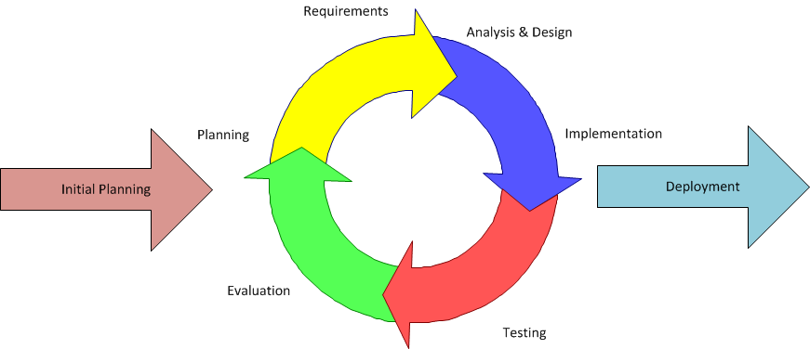

**Figure 2.1. Waterfall Model**

There are four (4) phases of the Iterative and Incremental Development which are the following: Inception, Elaboration, Construction, and Transition.

* **Inception**

The first step is to establish an initial plan and determine the functional and non-functional requirements to be estimated by identifying and defining the needs of the clinic in enough detail that work can be estimated. Questions that will be addressed in this phase are:

-What information from patients are needed by the clinic?

-What functionalities will be necessary for this system?

-Do you want to use this system instead of using pen and paper documentation?

* **Elaboration**

In this phase, design of the system will be delivered depending on the top needs of the clinic and fulfill the non-functional requirements determined from evaluation of previous iterations.

* **Construction**

In this phase the system will be incrementally improved with code produced from analysis, design, implementation, and testing of the functional requirements, before proceeding to deployment and re-evaluation.

* **Transition**

In this phase, the system is deployed for the clinic’s use. During deployment and testing, evaluation of the working system will be determined and should enhancements or improvements be needed, more iterations will occur until the desired system is implemented.

**CHAPTER 3**

**3.0 Review of Related Studies**

**3.1 Dental Clinic Management System**

The Dental Clinic Management System (DCMS) is a decision support system for Dental Clinics that provide information for the dentists about the patients such as patient information, dental treatment, billing, and appointments. (Dhanore, 2016)

**3.2 Dental Information System**

Dental Information System (DIS) designed for use in dental clinics. It provides information about the clinic, allows new patient registration and appointment booking. It also gives access to clinic patients their registered personal, medical and dental records, as stated in Dental Information System (2002) study from students of Universiti Utara Malaysia. (Zainab, 2002)

**3.3 Information Systems in Dentistry**

Information Systems in Dentistry according to the HL7 standard would represent electronic documents, eliminating the need for paper documents and a variety of daily and monthly report of doctors who are still in use today, and the doctor and nurse are almost complete freed of administrative tasks. (Masic, 2012)

**3.4 dentISt: Dental Information System 2.0**

Dental Information System 2.0, the second version of DentISt, gives UPCD clinicians free access and storage of electronic patient dental records. The system stores patient dental records containing different forms derived from the UPCD admitting section form. It also provides graphical representations of the teeth in which observations are easily added with just a few clicks.

This information system was developed by a computer science student from the University of the Philippines, Manila. (Balsita, 2012)

* 1. **Electronic Dental Records**

Electronic Dental Records (EDR) are dental records that that stored electronically, or by use of computers. Its use has become widespread amongst both the old and new practitioners of dentistry, making more data in electronic form available for research. (Schleyer, 2013)

**3.6 Dental Clinic Management System**

Dental Clinic Management System (DCMS) software is a comprehensive software solution for clinics that will help dentists keep track of patient dental problems, helping the patient improve awareness and take care of their oral health.

The data regarding the patient dental information will help determine the next treatment and also to be used for the future. (Salian, 2013)

* 1. **Design and Implementation of a Clinical Management System**

According to Greens et al., the criteria for the design of a clinical management system includes flexibility in its interface with the environment, the capability of handling variable length text string data, and of organizing it in tree-structured files, the availability of this data to a multi-user environment, and the existence of a high-level language facility for programming and development of the system. (Greens et al., 1969)

**CHAPTER 4**

**4.0 Theoretical Framework**

This chapter will discuss concepts that has been used throughout this study. These theories should be considered for the readers to understand the fundamental features of an information system for clinics.

**4.1 IT Related Theories**

**4.1.1 Information Systems**

Information Systems are formal, sociotechnical, organizational systems designed to collect, process, store, and distribute information. (Piccoli and Pigni, 2018)

**4.2.2** **Database Management System**

Database Management System is a system software that enables users define, create, maintain and control access to the database. (Connolly and Begg,2014)

**4.2.3 Transactional Processing System**

Transactional Processing System is a type of information system that collects, stores, modifies, and retrieves the data transactions of an enterprise. A reliable transactional system is defined under the acronym ACID, which means: atomicity, consistency, isolation, and durability. (Gray and Reuter, 2012)

**4.2.4 Human-Computer Interaction**

HCI (Human-computer Interaction) is the factor to the interfaces between users and computers, which allows users to interact with computers in novel ways. (Card and Thomas, 1980)

**4.2 Non-IT Related Theories**

**4.2.1 Reports**

A Report is a document that presents information in an organized format for a specific purpose, that can be delivered orally or in written documents. (Madan, 2016)

**4.3.0 Summary**

The theories above are the fundamentals that will make up this Dental Clinic Information System. These theories serve as foundations that make the system up and running, and will help the clinic in its’ transactions.

**CHAPTER 5**

**5.0 Data Gathering Procedures and Analysis of Outputs**

Data collection is the process by which data is gathered and measured. In this study, collected data will be used to tailor the information system being developed to the needs of the clinic. By implementing the appropriate data gathering techniques, the developed system will be determinably reliable with minimal undesired outputs.

**5.1 Data Gathering Techniques**

Data gathering techniques include interviews, observations and document analysis on existing sources such as articles, books, research papers or records. Combining these data gathering methods will enhance the credibility of the study.

**5.1.1 Interview**

Interviews are useful in inspecting views, ideas, or opinions. An interview can be structured, unstructured or semi-structured. Unstructured interviews are referred to as ‘in-depth’ interviews, consisting of open-ended questions that allow the discussion to cover areas in great detail. Semi-structured interviews allow the researcher to probe the interviewee by following questions with another one, which works best when the researcher wants to be clarified of the areas he wants to address. Lastly, a structured interview is done in such a way that the questions are given in order that a limited range of responses may be given. Close-ended questions are used to receive these clear and straightforward responses.

As an interview is the interaction between the researcher and the interviewee, the communication skills of the researcher are of great importance, in order to be able to communicate effectively, and receive responses that are of utmost precision and concision.

According to the owner of the De Ramos Dental Clinic, maintaining physical documents is a delicate task, and requires a systematic mindset and approach so as not to lose these documents. Also, these documents might get left alone for a long time as sometimes patients don’t have time for follow-up appointments.

**5.1.2 Observation**

Observation in qualitative research involves spending time within the setting. Notes are taken throughout the observation process to help in determining what the observed events or materials might mean. This provides help in answering research questions during future analysis. Observation can also serve as a way of verifying or invalidating information gathered through other data collection techniques.

This study uses Structured Observation of the Environment (STROBE) as a method of information gathering through observation. This is a technique for observing the decision maker’s environment such as the office location, desk placement, stationary equipment, props, external information sources, office lighting and clothing worn by the decision makers. Aside from that, an analyst’s playscript is also used to understand and articulate the actions taken by each observed decision maker. These actions include talking, sampling, corresponding and deciding. Through the playscript, additional information about the decision makers will be gathered for further use in this study.

**5.1.3 Document Analysis**

Document analysis is a form of qualitative research in which documents are interpreted by the researcher to give voice and meaning around an assessment topic. This includes documents like workbooks, journals and other business forms. Through these gathered documents, additional data can be considered in ensuring that the research is inclusive, making this process far more time and cost-efficient compared to other data-gathering techniques.

The full documentation of all the forms gathered are attached in the Appendices section of this study.

**5.2 Analysis of Outputs**

**5.2.1 Interview**

The interviewee was the owner of the De Ramos Dental Clinic. She used to work as a dentist of a large clinic in Manila prior to establishing her own private dental clinic here in Laguna. She has two soon-to-be dentists working under her wing as assistants.

During the interview, the owner said, that she has been looking for a way to transact electronically, as pen-and-paper documents are inefficient and can be unorganized. The number of patients she receives both new and old require pen-and-paper documents in each transaction, and as such, these pile up in the small office of her private clinic. As such, it has become inconvenient and tedious that every patient’s visit adds documents to the pile, and requires searching through the pile for references of previous visits.

The interview and data gathered shows that De Ramos Dental Clinic are having problems concerning manual record keeping and rely on their old systematic approach of alphabetically ordered cabinet of documents.

**5.2.2 Observation**

The De Ramos Dental Clinic is located in Biñan, Laguna. The business tools and equipment observed include a desktop computer, a few file cabinets, medical tools, medical cabinets, logbooks, mobile phones, telephones and calculators. All transactions are done inside the clinic, and as such they have a waiting room for the people waiting in line for their appointment with the dentist, along with a small cabinet of books and magazines, and the operation room with a dental chair and bright lighting conditions. The clothing worn by the dentists are relaxed and informal underneath a white lab gown, and wear gloves and masks during operations.

The owner can be viewed as a straightforward and decisive person. The way she talks seemed she is knowledgeable of the clinic’s operations.

**5.2.3 Document Analysis**

The documents that were gathered collected data necessary to the documentation of patients. These forms required the patient’s name, address, contact information, body mass index (BMI), and the patient’s medical background.

A treatment form, which listed down the teeth number, date, diagnosis, and treatment done was also gathered.

By analyzing the business forms, it shows that De Ramos Dental Clinic receives and stores a lot of data for each transaction. This means that more and more forms will be used should more transactions continue, making pen and paper documentation not only inefficient, but also tedious and time consuming.

**5.3 Summary**

In this chapter, necessary data were gathered to determine which type of system this study needs to implement. By using the aforementioned data gathering techniques, key information for the analysis and design of the proposed system was collected.

The proposed information system will be advantageous for the dentists to cut down the tedium of inefficient and sparingly organized pen-and-paper documentation, as well as simplify the administrative tasks otherwise faced by the dentists of De Ramos Dental Clinic.

**CHAPTER 6**

**6.0 Documentation of the Current System**

The De Ramos Dental Clinic provides operations and documents their day-to-day activities manually. The diagrams in this chapter are provided to fully illustrate the activities regarding their business process.

**6.1 Description of the Current System**

Currently, The De Ramos Dental Clinic uses pen-and-paper documentation for transactions. A patient is asked to fill out a form that requires details such as name, date of birth, body-mass index, contact information, and medical history. Children under 18 will not be seen unless accompanied by a parent or guardian. Patients must have their current health information with all prescribed medications. After an operation, a treatment card is filled up, adding to the patient’s medical history, in which details such as which tooth and what diagnosis and treatment was applied is listed. If needed, a prescription is then given and a follow-up appointment is scheduled. It is a patient’s responsibility to remember their appointment time, but will be reminded with a courtesy call. Broken appointments will be noted and added to a patient’s record.

**6.1.1 Context Diagram**

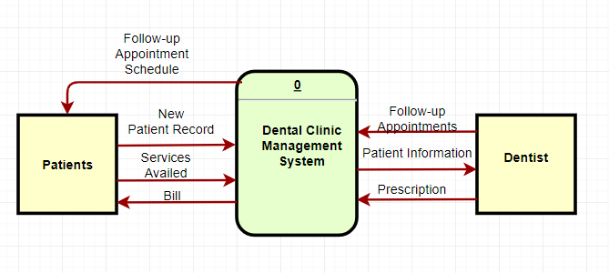

**Figure 6.1. Context Level Data Flow Diagram of the De Ramos Dental Clinic’s Current Management System**

Figure 6.1 illustrates the context diagram of the existing system. Based on the figure, a patient will provide their medical record which will be input into the system and read by the dentist, who in turn will provide possible prescriptions, and schedules of follow-up appointments.

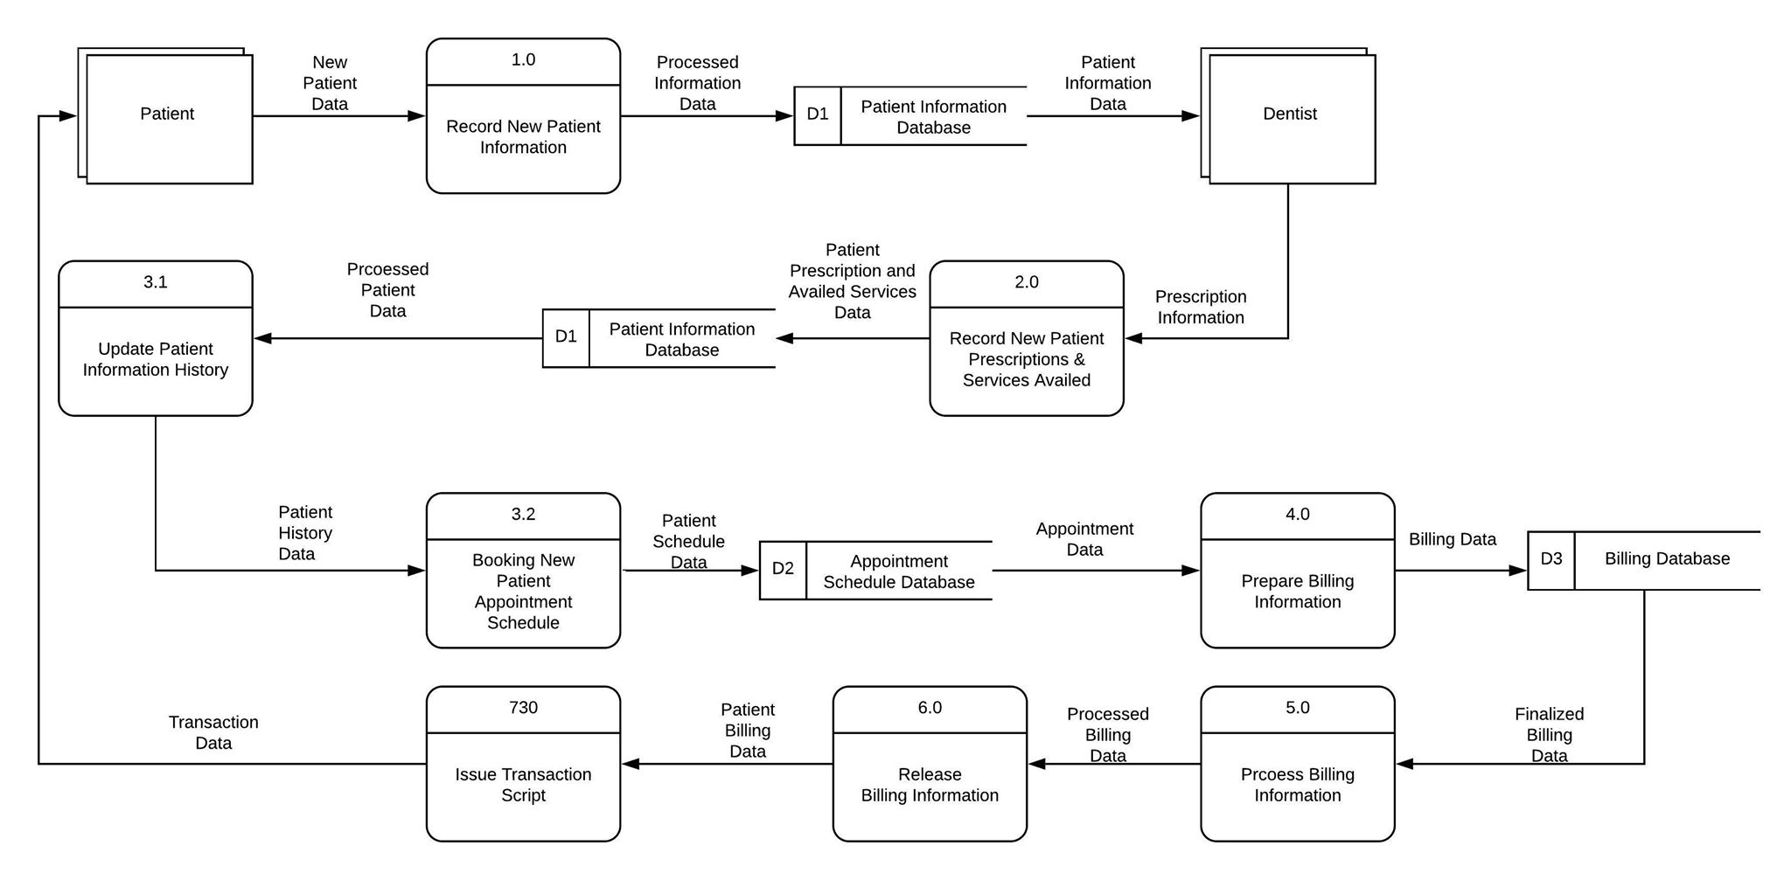

**FIGURE 6.2 Exploded View of the CFD of the Current System**

The difficulties encountered with the existing system comes with the tedium of inefficient and sparingly organized pen-and-paper documentation, because as patients visit and revisit, more and more treatment cards will be used, resulting in inefficiency, and redundancy of information.

**6.2 Hardware and Equipment Set-up**

The De Ramos Dental Clinic uses a desktop computer to manually schedule future appointments of clients. They also have several file cabinets where they keep all their documents in alphabetical order

**6.3 Software and Applications being used**

The De Ramos Dental Clinic uses the Sticky Notes and Calendar apps of Windows 7 in order to list down schedules of appointments, and unfulfilled or partially fulfilled payments.

**6.4 Personnel**

The dentist Caroline E. De Ramos is the owner of the De Ramos Dental Clinic, as well as the only dentist, having part-time assistants only when needed.

**CHAPTER 7**

**7.0 System Design Specification**

This section shows models that depict the flow of information of the De Ramos Dental Clinic Information System and the functional requirements of the proposed system.

**7.1** **Architectural Design**

The system contains a login module for security purposes to prevent mishandling of documentation. A main menu will then show up after logging in. In this main menu, the user can choose from different buttons depending on the transactions that will be made. In the ‘records’ button, the user can choose to add a new patient to the system, update an existing patient’s record, or view the transactions that were made by the patient concerning previous visits. In the ‘transactions’ button, the user can choose to view the tallying of services, and the login history of the users who have logged in the system.

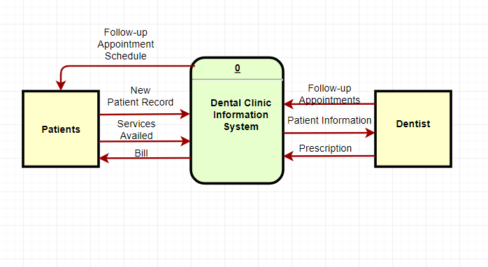

**Figure 7.1. Context Flow Diagram of the Proposed System**

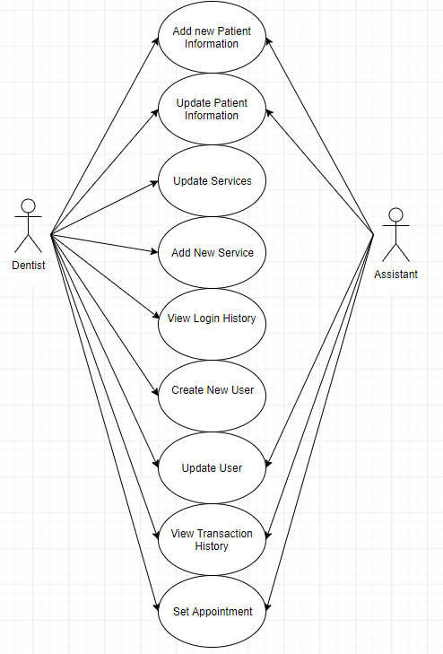

**FIGURE 7.1.2. Use-case of the Proposed System**



**Figure 7.2. Diagram 0 of the Proposed System**

**7.2 System Functions**

**Login Module : The first form of this program**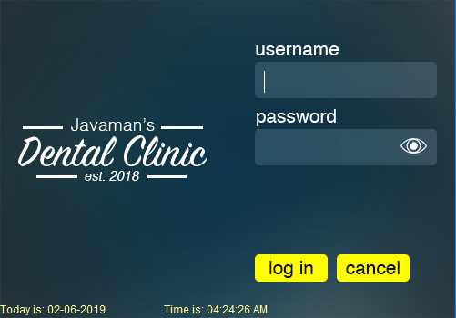

**7.2.1.Main Menu: - The Master page of this program**

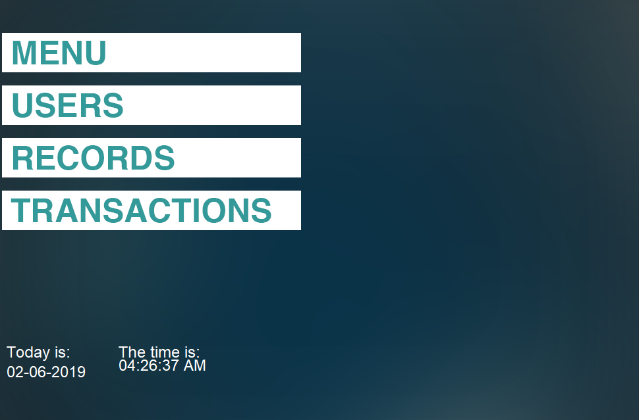

**7.2.2. New Patient Record: Initial fill-up for new patients**

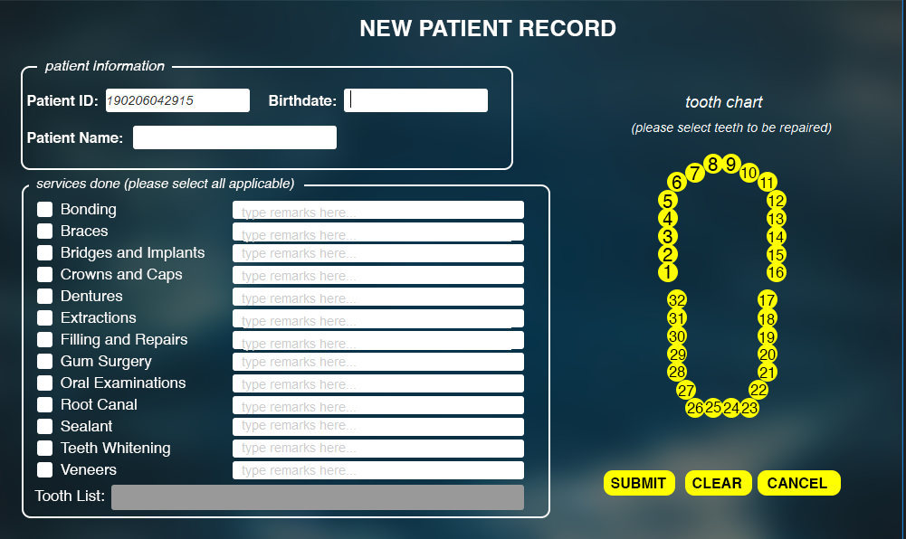

**7.2.3. Update Patient Record: For existing patients**

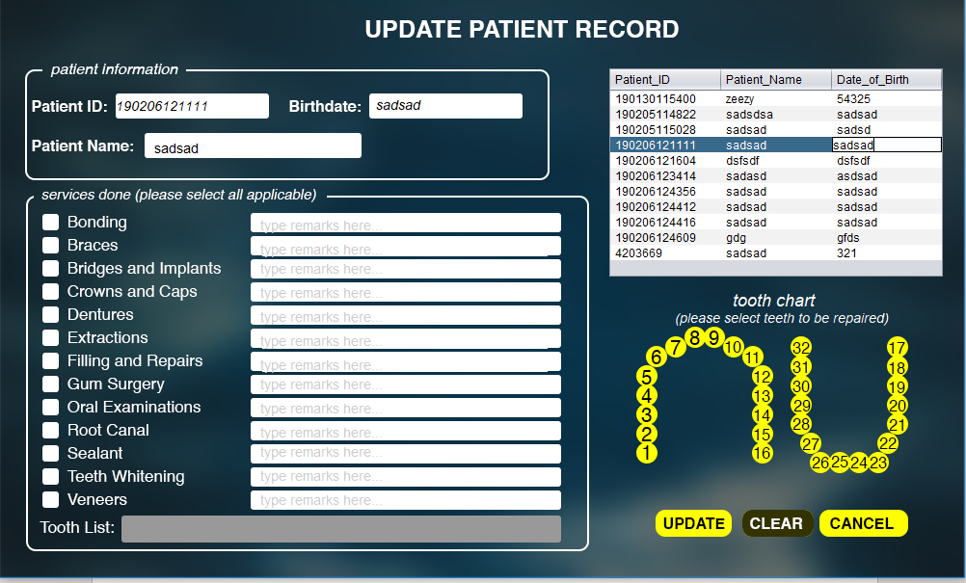

**7.2.4. Services Form: Where you can add services or update Rates of services.**

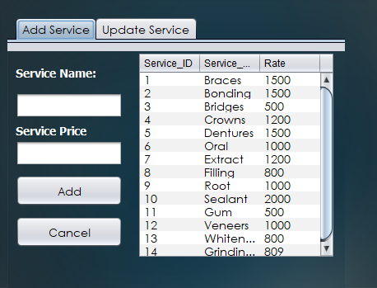

**7.2.5. Create New User Form**

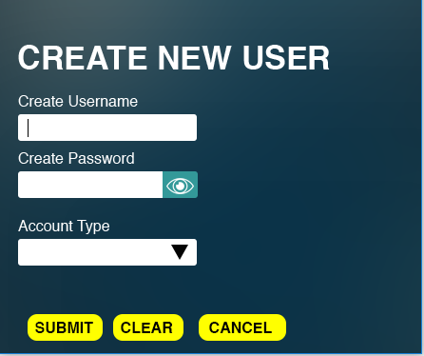

**CHAPTER 8**

**8.0 Recommendation and Conclusion**

**8.1 Recommendation**

In conclusion, this proposed information system can immensely improve the efficiency of operations and administrative tasks of the clinic, by replacing and automating most of their pen and paper documentations preventing the tedious tasks of previously handsearching documents through piles of compiled paperwork.

**8.2 Conclusion**

This proposal can further be improved by implementing a website that can connect all branches of the clinic, adapting also an online approach that will be open to patients, as well as improve communication between dentists and patients for the betterment of their oral health.

**Bibliography**

Dhanore, P. (2016, May). *Dental Clinic Management System* *– A New Approach*. Retrieved from http://ijcset.net/docs/Volumes/volume6issue5/ijcset2016060507.pdf

Zainab Bee, Hamid (2002) *Dental Information System*. Masters’ thesis, Universiti Utara Malaysia.

Masic, F. (2012, March 20). *Information Systems in Dentistry*. Retrieved from https://www.ncbi.nlm.nih.gov/pmc/articles/PMC3545321/

Balsita, M. B. (2012, April). *DentISt: Dental Information System 2.0*. Retrieved from

<http://dspace.cas.upm.edu.ph/jspui/bitstream/123456789/13/1/Dental%20Information%20System%202.0%20%28DentISt%29%20by%20Cristina%20Balsita%20SP%20Docs%20II.pdf>

Schleyer et al. (2013, Jan). *Electronic dental record use and clinicial information management patterns among practitioner-investigators in The Dental Practice-Based Research Network.* Retrieved from https://www.ncbi.nlm.nih.gov/pmc/articles/PMC3539217/

Salian, Talik (2013, Jan). *Dental Clinic Management System*. Retrieved from <https://www.scribd.com/doc/241330858/Dental-Clinic-Management-System-Jonan?fbclid=IwAR0UB9PCDP2jGB3FP0jGYldRndmuQOnd1_PI-tk5lTspo9T-GTm8pcWkWAA>

Greens et al. (1969). *Design and Implementation of a clinical management system.* Computer Biomedical Research 2(5): 469-485

Piccoli, Gabriele; Pigni, Federico. Information systems for managers: with cases (Edition 4.0 ed.). Prospect Press. p. 28. ISBN 978-1-943153-50-3. Retrieved 25 November 2018.

Connolly, Thomas M.; Begg, Carolyn E. (2014). Database Systems – A Practical Approach to Design Implementation and Management (6th ed.). Pearson. ISBN 978-1292061184.

Gray, Jim; Reuter, Andreas. "Transaction Processing – Concepts and Techniques (Powerpoint)". Retrieved Nov 12, 2012.

Card, Stuart K.; Thomas P. Moran; Allen Newell (July 1980). "The keystroke-level model for user performance time with interactive systems". Communications of the ACM. 23 (7): 396–410. doi:10.1145/358886.358895.

Madan, Poonam (2016/17). Language proficiency in English. 28/115, jyoti block, sanjay place, Agra-2: Agarwal publication. p. 138. ISBN 9789385872280

**Appendix A**

**Letter of Request**

November 7, 2018

**Caroline E. De Ramos**

Owner, De Ramos Dental Clinic

B7 L6 St. Paul Street St. Francis 7 Subd., San Antonio Biñan Laguna

Dear Dr. Caroline De Ramos,

Good Day!

I am a Computer Science student from Malayan Colleges Laguna. One of my major courses is System Analysis and Design with IT concepts which requires us to identify, define and document business problems and develop information system models to solve these problems using various tools learned in the course.

In this regard, I am seeking for your approval to conduct a feasibility study that could help me to achieve my goal. Rest assured that the gathered data will be used for the fulfilment of the course and will be handled appropriately. Should you have any inquiries you may send an email to our course adviser at ranayang@mcl.edu.ph.

We are looking forward for a favourable response regarding this matter.

Thank you very much

Sincerely,

_______________

Cruzald C. Boholst

Noted by:

________________

**Ms. Rhea N. Tortor**

Course Adviser, College of Computer and Information Science

Malayan Colleges Laguna

**APPENDIX B**

**SAMPLE TREATMENT CARD FORM**

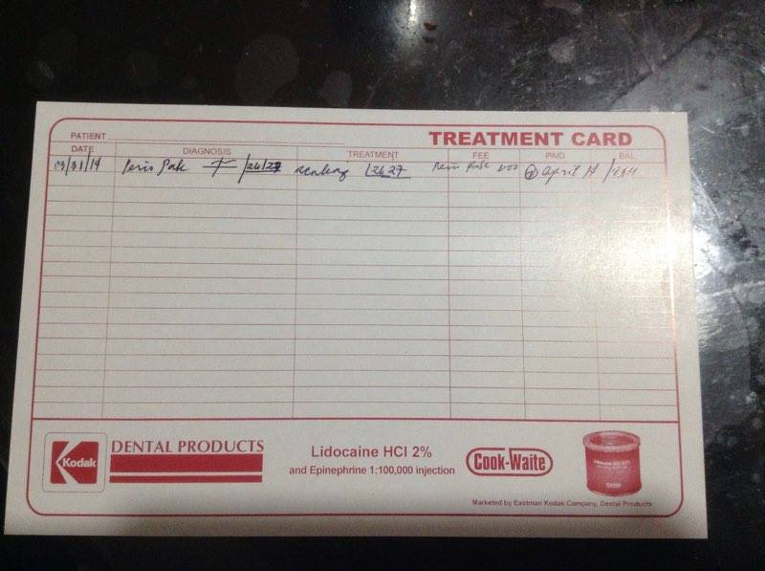

**APPENDIX C**

**SAMPLE DENTAL PATIENT RECORD FORM**

